DS LAB1 TASKS
NAME: MUHAMMAD ANAS | SECTION: BCS-3A | ID: 25K-0577
Q3:
CODE:
#include <iostream>
using namespace std;

int main(){
int n;
cout << "Enter number of students: ";
cin >> n;

//allocating the array
int* arr = new int[n];

int max = 0;
int min = 999;

for(int i=0; i<n; i++){
cout << "Enter Student " << i+1 << " marks: ";
cin >> arr[i];

if(arr[i] > max) max = arr[i];
if(arr[i] < min) min = arr[i];
}

for(int i=0; i<n; i++){
cout << "Student " << i+1 << " marks = " << arr[i] << endl;
}

cout << "\nHighest Marks: " << max << endl;
cout << "Minimum Marks: " << min << endl;

//deallocating array
delete[] arr;

return 0;
}

OUTPUT:
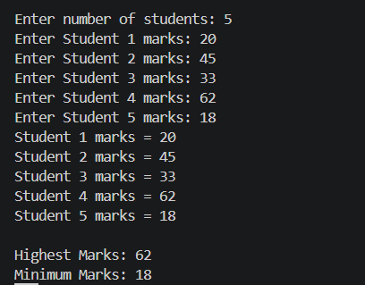

Q4:
CODE:
#include <iostream>
#include <cstring>
using namespace std;

class Exam{
char *studentName;

public:
Exam(char* name){
studentName = new char[strlen(name)+1]; //dynamically allocating memory in the heap
strcpy(studentName, name); //copying the name
}

void display(){
cout << "Name: " << studentName << endl;
}

~Exam(){
delete[] studentName;
}
};

int main(){
Exam e1("Anas"); //object memory is created here
Exam e2("Ali"); //another object memory is created here

e1.display();
e2.display();
}

OUTPUT:
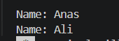
Q5:
CODE:
#include <iostream>
#include <cstring>
using namespace std;

class Exam{
char *studentName;

public:
Exam(char* name){
studentName = new char[strlen(name)+1];
strcpy(studentName, name);
}

void setName(char* name){
strcpy(studentName, name);
}

void display(){
cout << "Name: " << studentName << endl;
}

~Exam(){
delete[] studentName;
}
};

int main(){
Exam e1("Anas");
Exam e2 = e1;

e1.display();
e2.display();

e2.setName("Ali");

e1.display();
e2.display();
}

OUTPUT:
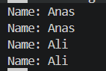
“Here as we can see that after calling the setName function for e2 will automatically changes the name of e1 because at that time the shallow copy is called and it is not creating different addresses it is just changing the value of e2 and e2,e1 both points towards the same address that’s why e1 name also changes .
e1 -> address <- e2 “

Q6:
CODE:
#include <iostream>
#include <cstring>
using namespace std;

class Exam{
char *studentName;

public:
Exam(char* name){
studentName = new char[strlen(name)+1];
strcpy(studentName, name);
}

void setName(char* name){
strcpy(studentName, name);
}

Exam(const Exam &other){
studentName = new char[strlen(other.studentName)+1];
strcpy(studentName, other.studentName);
}

void display(){
cout << "Name: " << studentName << endl;
}

~Exam(){
delete[] studentName;
}
};

int main(){
Exam e1("Anas");
Exam e2 = e1;

e1.display();
e2.display();

e2.setName("Ali");

e1.display();
e2.display();
}

OUTPUT:
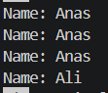

“As we can see in this example that we are not only copying values also we are creating two different addresses”
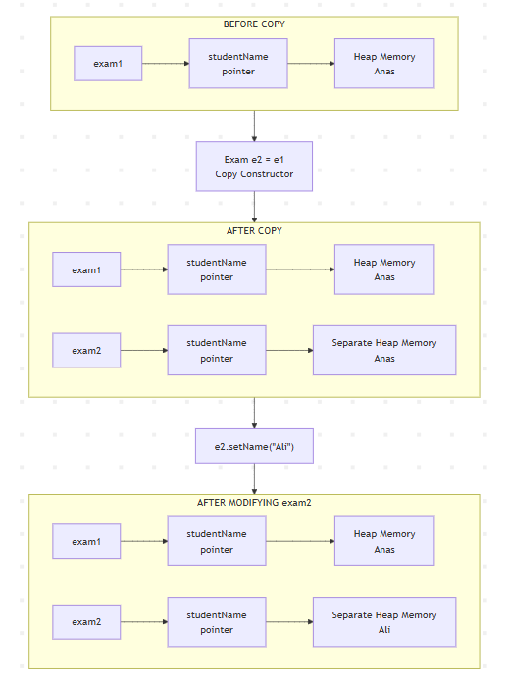

Q7:
CODE:
#include <iostream>
using namespace std;

class student
{
private:
int *marks;

public:
student(int m)
{
marks = new int(m);
}

student(const student &other)
{ // Proper copy constructor
marks = new int(*other.marks);
}

student &operator=(const student &other)
{
if (this != &other)
{
delete marks;
marks = new int(*other.marks);
}
return *this;
}

void display()
{
cout << "Marks: " << *marks << endl;
}

void modify(int m)
{
delete marks; // Release old heap memory
marks = new int(m);
}

~student()
{
delete marks;
}
};

int main()
{
student s1(80);
student s2 = s1; // invokes copy constructor
student s3(90);
s3 = s1; // invokes copy assignment operator
cout << "Before modification:" << endl;
cout << "s1: ";
s1.display();

cout << "s2: ";
s2.display();

cout << "s3: ";
s3.display();
s2.modify(70);
s3.modify(60);

cout << "\nAfter modification:" << endl;
cout << "s1: ";
s1.display();

cout << "s2: ";
s2.display();

cout << "s3: ";
s3.display();

return 0;
}

OUTPUT:
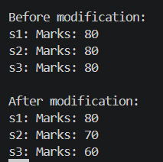

Q8:
CODE:
#include <iostream>
using namespace std;

class Box {
private:
int *value;

public:
Box(int v) {
value = new int(v);
}

Box& operator=(const Box &other) {

if (this != &other) {
cout << "Releasing old memory \n";
delete value;
value = new int(*other.value);
cout << "New memory allocated \n";
}
else{
cout << "Self-assignment detected, skipping\n";
}
return *this;
}

void display() {
cout << "Box value: " << *value << endl;
}

~Box() {
cout << "Destructor called "<< *value << endl;
delete value;
}
};

int main() {
Box box1(10);
Box box2(20);

box2 = box1;
box1.display();
box2.display();

box1 = box1;
box1.display();

return 0;
}

OUTPUT:
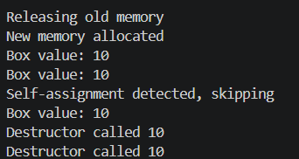

Q9:
CODE:
#include <iostream>
using namespace std;

class box
{
private:
int *num;

public:
box(int m)
{
num = new int(m);
}

box(const box &other)
{ // Proper copy constructor
cout << "copy constructor is called" << endl;
num = new int(*other.num);

cout << "New memory allocated for copied object with value: " << *num << endl;
}

box &operator=(const box &other)
{
cout << "copy assignment operator is called" << endl;
if (this != &other)
{
delete num;
num = new int(*other.num);
}

else
{
cout << "Self-assignment detected. No memory changed." << endl;
}
return *this;
}

void display()
{
cout << "Value: " << *num << endl;
}

void modify(int m)
{
cout << "Call for modification: " << endl;
cout << "Modifying value from " << *num << " to " << m << endl;
delete num; // Release old heap memory
num = new int(m);
}

~box()
{
cout << "Destructor is called" << endl;
delete num;
}
};

int main()
{
cout << "===== Creating box1 =====" << endl;
box box1(80);

cout << "\n===== Creating box2 =====" << endl;
box box2(90);

cout << "\n===== Copying box1 into box3 =====" << endl;
box box3 = box1;
cout << "box1: ";
box1.display();

cout << "box2: ";
box2.display();

cout << "box3: ";
box3.display();

cout << "\n===== Modifying box1 =====" << endl;
box1.modify(60);
cout << "box1: ";
box1.display();

cout << "box3: ";
box3.display();
cout << "\n===== Assigning box1 to box2 =====" << endl;
box2 = box1;

cout << "box1: ";
box1.display();

cout << "box2: ";
box2.display();
cout << "\n===== New scope =====" << endl;

{
box box4(200);

cout << "box4: ";
box4.display();

box box5 = box4; // Copy constructor

cout << "box5: ";
box5.display();

box5.modify(300);

cout << "After modifying box5:" << endl;

cout << "box4: ";
box4.display();

cout << "box5: ";
box5.display();

cout << "inner scope ended" << endl;
}
cout << "\n===== End of main =====" << endl;
return 0;
}

OUTPUT:
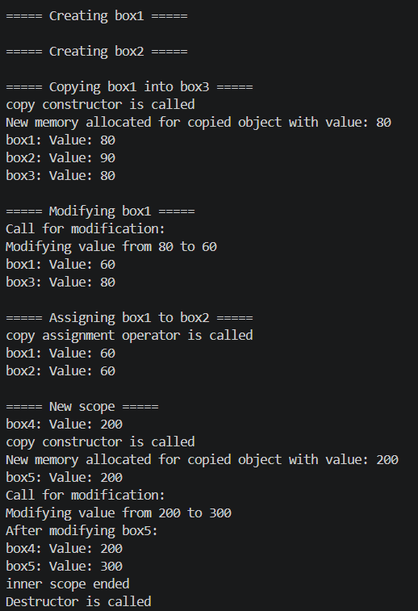
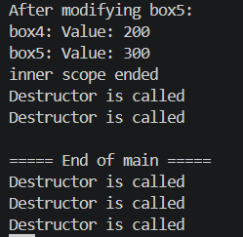

Q10:
CODE:
#include <iostream>
#include <string>
#include <cstring>

using namespace std;

class StudentRecord
{
private:
char *name;
int *marks;
int size;

public:
StudentRecord(const char *n, int s)
{
name = new char[strlen(n) + 1];
strcpy(name, n);
size = s;
marks = new int[size];
cout << "Enter " << size << " marks of student: " << name << endl;
for (int i = 0; i < size; i++)
{
cin >> marks[i];
}
}

StudentRecord(const StudentRecord &other)
{
cout << "[Copy Constructor] copying from " << other.name << endl;
name = new char[strlen(other.name) + 1];
strcpy(name, other.name);
size = other.size;

marks = new int[size];
for (int i = 0; i < size; i++)
{
marks[i] = other.marks[i];
}
}

StudentRecord &operator=(const StudentRecord &other)
{
cout << "[Copy Assignment] " << name << " assigned from " << other.name << endl;
if (this != &other)
{
delete[] name;
delete[] marks;
name = new char[strlen(other.name) + 1];
strcpy(name, other.name);
size = other.size;

marks = new int[size];
for (int i = 0; i < size; i++)
{
marks[i] = other.marks[i];
}
}
return *this;
}

void setMark(int index, int value)
{
if (index >= 0 && index < size)
{
marks[index] = value;
}
}

void display()
{
cout << "Marks of student " << name << endl;
for (int i = 0; i < size; i++)
{
cout << marks[i] << " ";
}
cout << endl;
}

~StudentRecord()
{
cout << "Destructor " << name << " destroyed\n";
delete[] name;
delete[] marks;
cout << endl;
}
};

class BrokenRecord
{
private:
int *marks;
int size;

public:
BrokenRecord(int s)
{
size = s;
marks = new int[size];
cout << "Enter " << size << " marks of student: " << endl;
for (int i = 0; i < size; i++)
{
cin >> marks[i];
}
}

void setMark(int index, int value)
{
marks[index] = value;
}

void display()
{
cout << "Marks of student " << endl;
for (int i = 0; i < size; i++)
{
cout << marks[i] << " ";
}
cout << endl;
}

~BrokenRecord()
{
cout << "Destructor BrokenRecord destroyed\n";
delete[] marks; // shallow copy ki wajah se ye DOUBLE DELETION karega
}
};

int main()
{
StudentRecord s1("Anas", 3);
StudentRecord s2("Ali", 2);
StudentRecord s3("Ahmed", 3);

StudentRecord s4 = s1;

s3 = s1;
s1 = s1;
cout << endl;

s2.setMark(0, 11);
s3.setMark(0, 22);

s1.display();
s2.display();
s3.display();
s4.display();

cout << "\nNested Scope\n";
{
StudentRecord s5 = s1;
s5.display();
}

{
BrokenRecord b1(2);
BrokenRecord b2 = b1;
b2.setMark(0, 999); // b2.setMark(0, 999) karne se b1 bhi affect hoga (shared data)
b1.display();
b2.display();

// DOUBLE DELETION -> undefined behavior / crash
}
}

OUTPUT:
